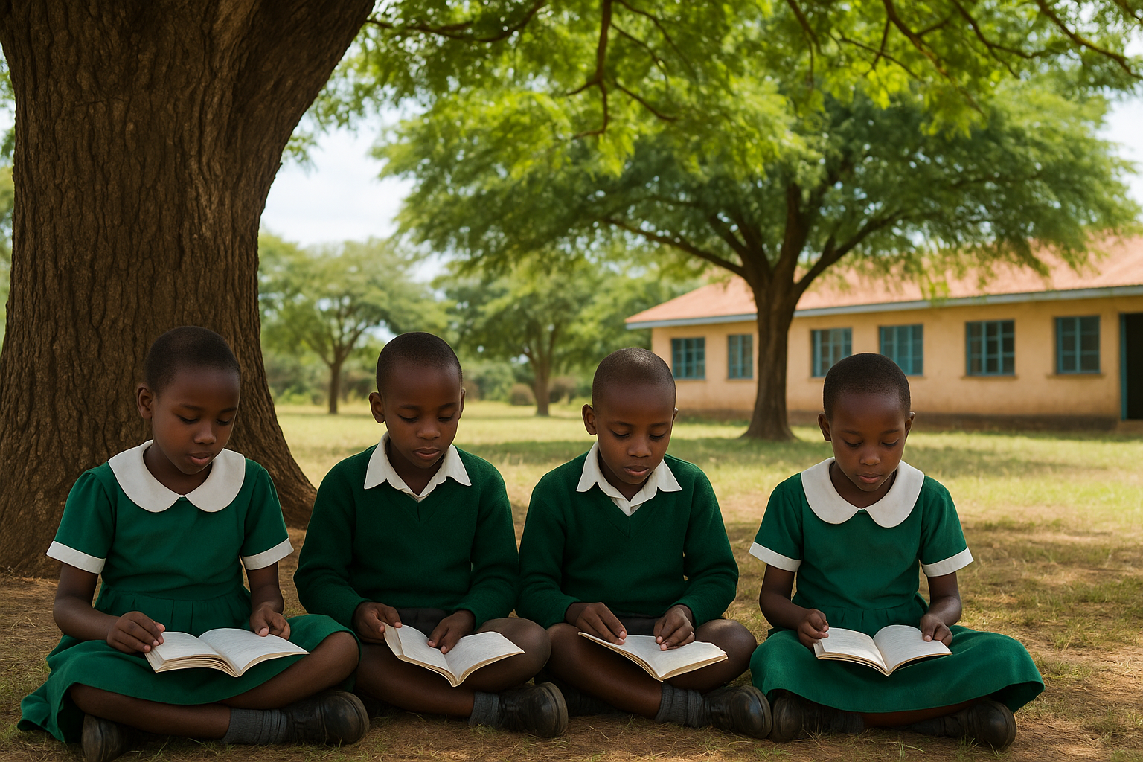

**Will the Next Generation Inherit Shade-or Only Memories: Why Greening schools is key to Kenya’s Afforestation Agenda**

There was a time when classrooms were not bound by walls. Children gathered under the broad canopy of a mugumo or jacaranda, their lessons carried by the wind, their first blackboard the open sky. Schools were once living ecosystems: compounds lined with neem, grevillea, and acacia; playgrounds softened by shade; fresh air moving freely through lessons. Planting a tree when you joined a school was not just a ritual it was an investment in memory and belonging.

Today, that picture has faded. A 2021 Ministry of Education survey found that **less than one in three public schools** now have adequate tree cover. Concrete blocks dominate, trapping heat that regularly pushes classroom temperatures above **35°C**. Playgrounds are bare and dusty; when the rains come, they flood. What was once a natural classroom has become an environment that mirrors the wider ecological unraveling around us.

The National Environment Trust Fund (NETFUND) has been leading efforts to change this story. Through supporting local communities across the country with tree seedlings, it has made it possible for schools, hospitals, and public spaces to slowly recover their green cover. The Fund has been working with communities to take up the responsibility in a bid to revert the situation.

Through this programs, NETFUND has supported the planting of thousands of trees in schools, farms, and degraded lands restoring the shade that once defined learning spaces and stabilizing the watersheds that sustain food and water security.From the drylands of Kajiado & Garissa to critical water catchments like the Mau, Maragoli hills, and Cherangany, NETFUND has over the last couple of years distributed over 2,000,000 seedlings to schools & community groups to promote this greening initiative. They are a deliberate re-engineering of Kenya’s “natural infrastructure” forests, wetlands, and soils that provide invisible but essential services to the economy.

The President has set an ambitious target of growing 15 billion trees by 2032, a call that demands participation at every level of society. Achieving this goal requires more than planting seedlings it requires cultural renewal. Schools must once again become hubs of environmental stewardship, where students not only learn from books but also from the trees they plant and care for. Communities must be equipped with seedlings, knowledge, and support to restore degraded lands and protect water catchments.

There is also a justice dimension to the greening agenda. Children in under-resourced schools often sit through scorching heat in bare compounds, while wealthier schools enjoy cooler, greener surroundings. Planting trees in schools is not an act of charity it is an act of equalizing opportunity, ensuring that no child learns under conditions that sap health and attention, said the CEO of NETFUND.

“The question is not whether to green our schools, but how fast we can make it happen. Kenya’s 15 billion tree target will only be credible if schools, hospitals, and community spaces are prioritized alongside forests and farms. At NETFUND, we provide seedlings and support, but the daily act of care belongs to teachers, students, and parents. This is a civic revival, as much cultural as it is ecological,” the CEO added.

Biodiversity is not nostalgia. It is wealth, trees, rivers, soils, and species that act as infrastructure, silently sustaining our food, water, and health systems. However, to neglect them is to run up a debt future generation cannot repay. To protect them is to multiply an inheritance.

The image of a child learning under a tree should not remain a sepia-tinted memory. It must be a vision of tomorrow, where schools are green, resilient, and alive with the sound of both lessons and leaves. With NETFUND mobilizing resources and communities carrying forward the work, Kenya stands at a crossroads. The choice is stark: act boldly now and gift the next generation shade, health, and belonging or hesitate and leave them only stories of what once was.